GET http://localhost:8888/api/employees

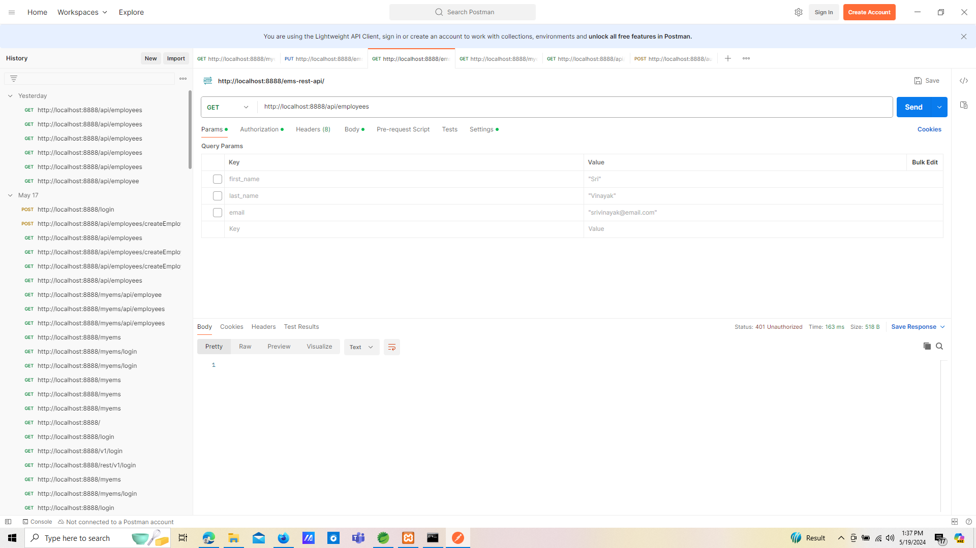

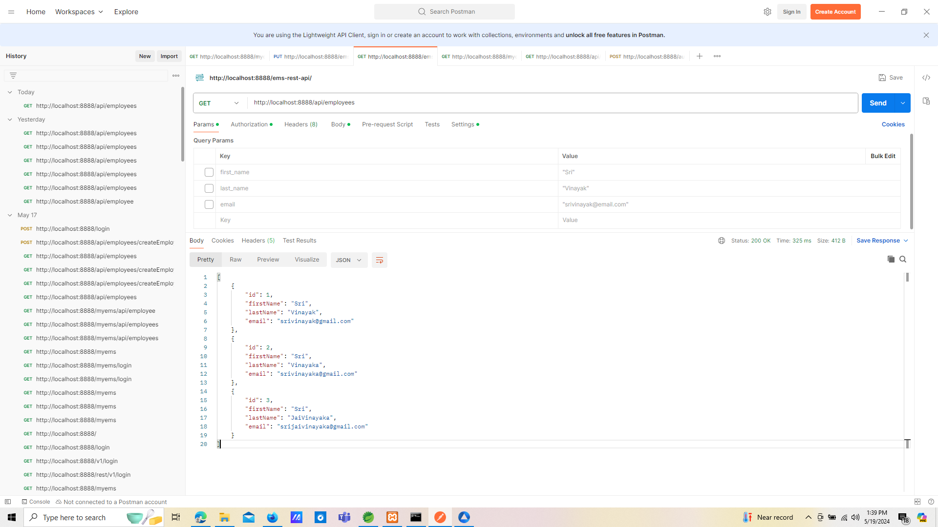

POST http://localhost:8888/api/employees/createEmployee

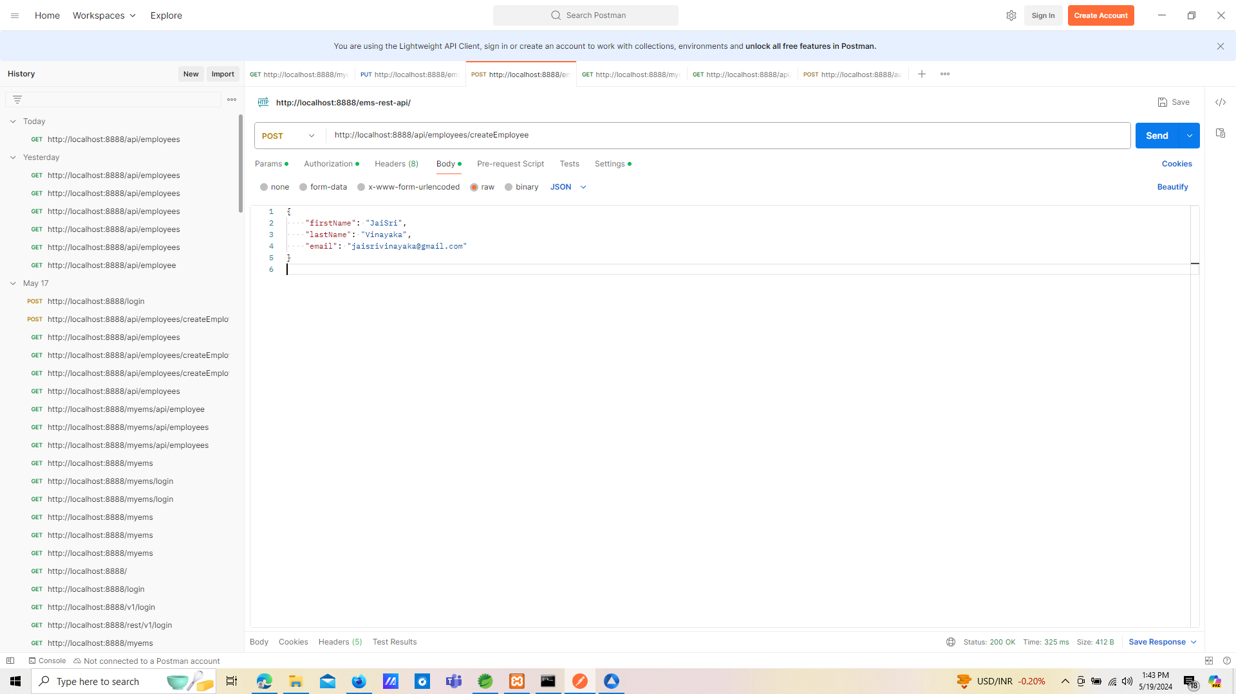

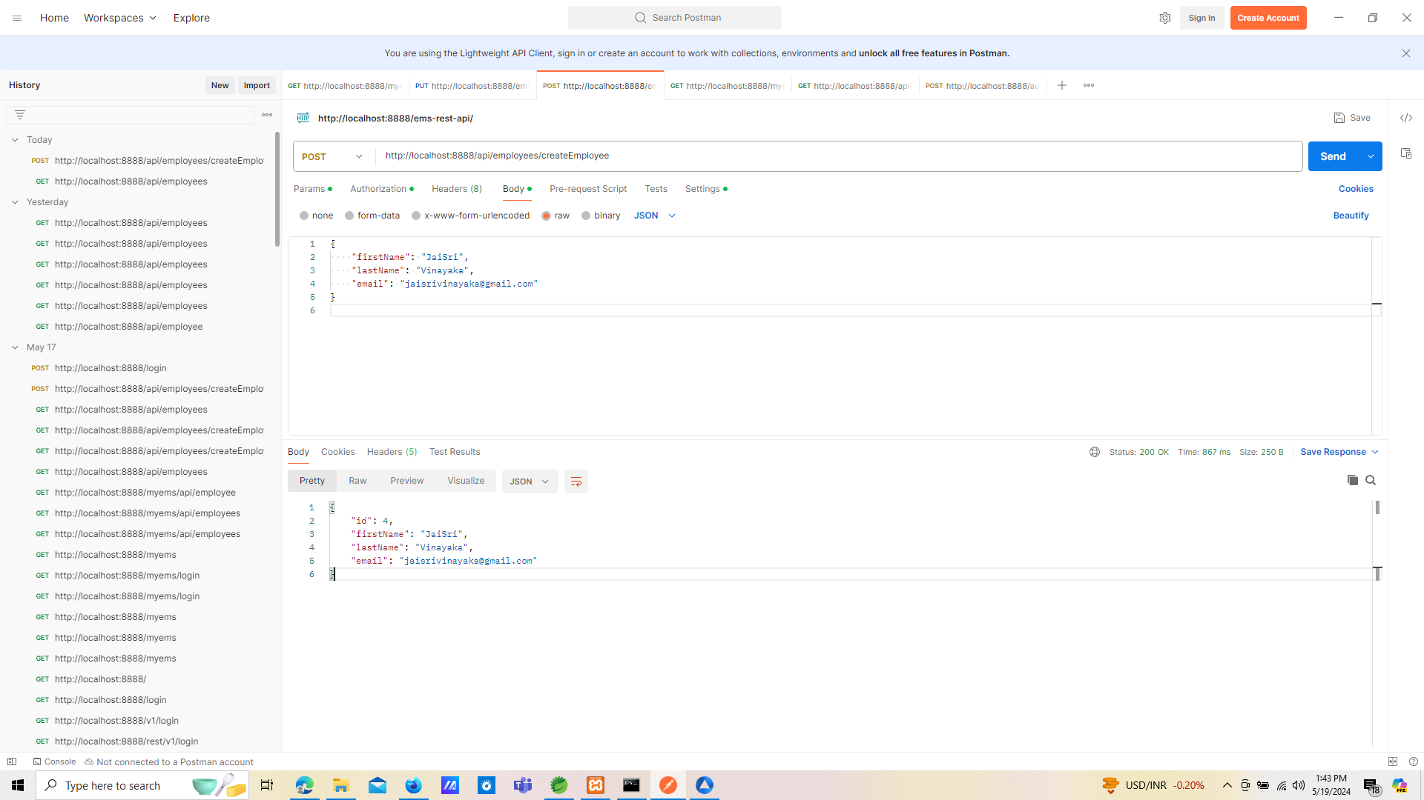

GET http://localhost:8888/api/employees/2

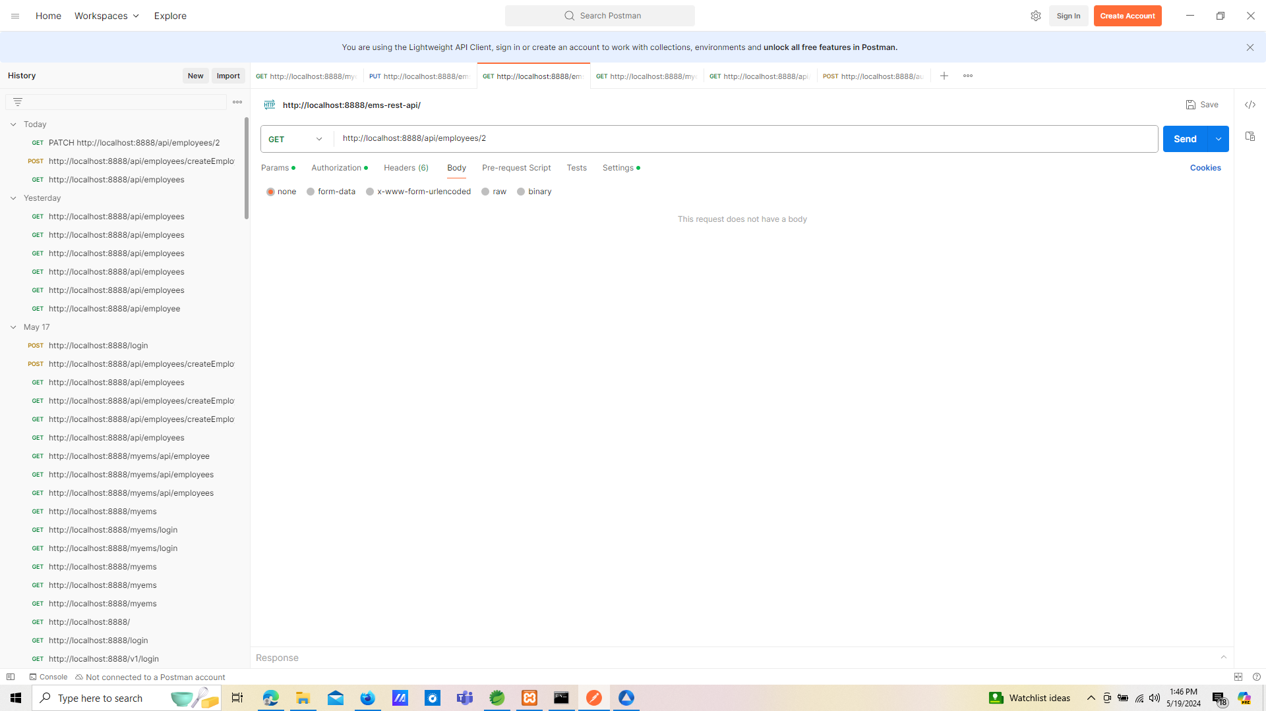

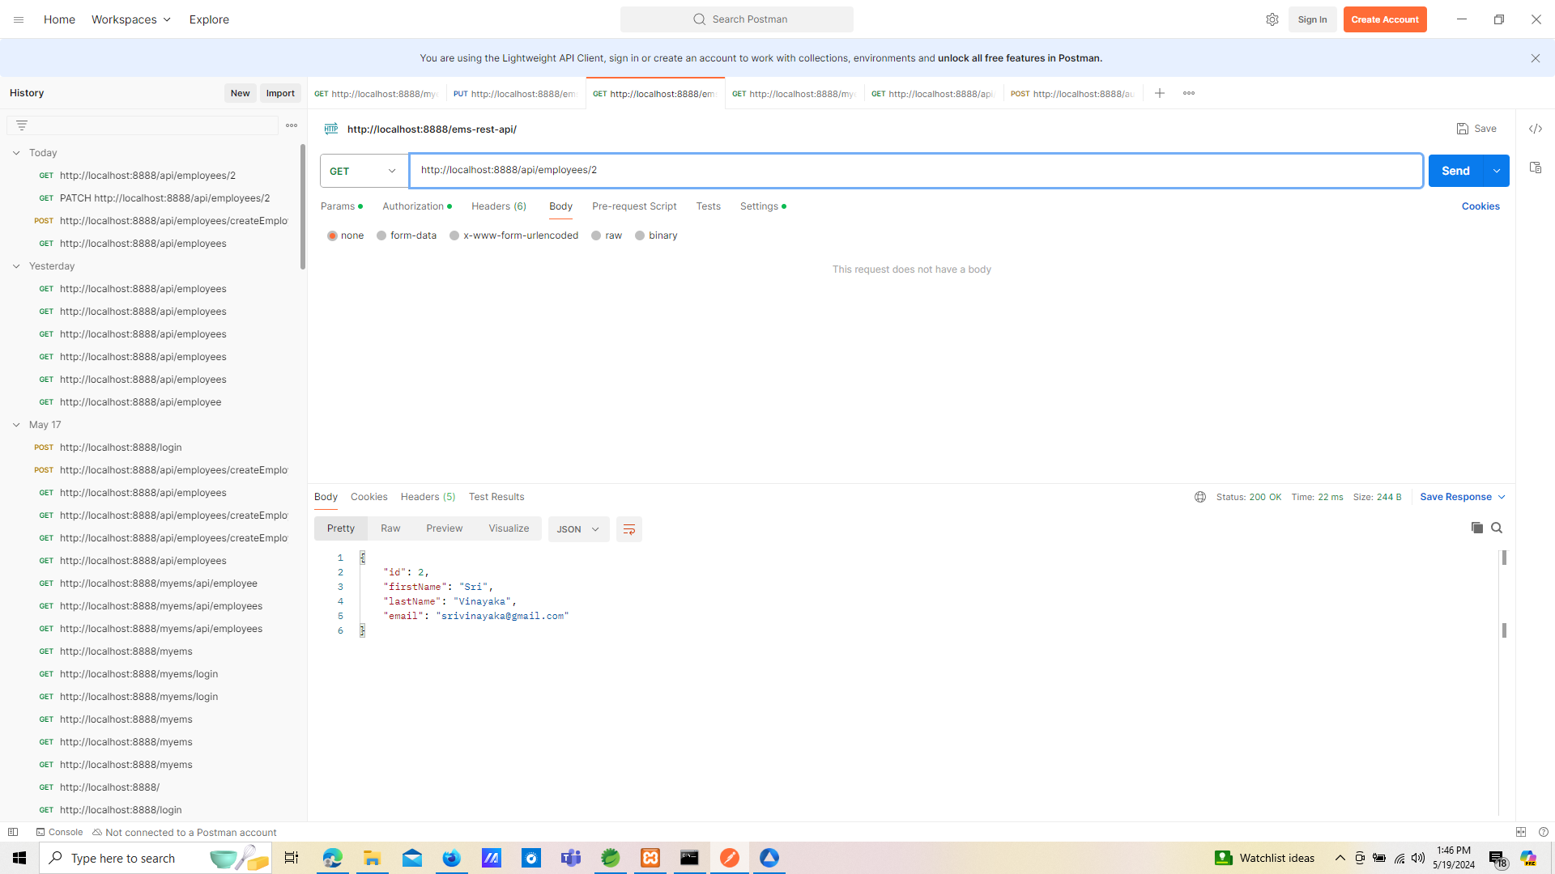

PATCH http://localhost:8888/api/employees/2

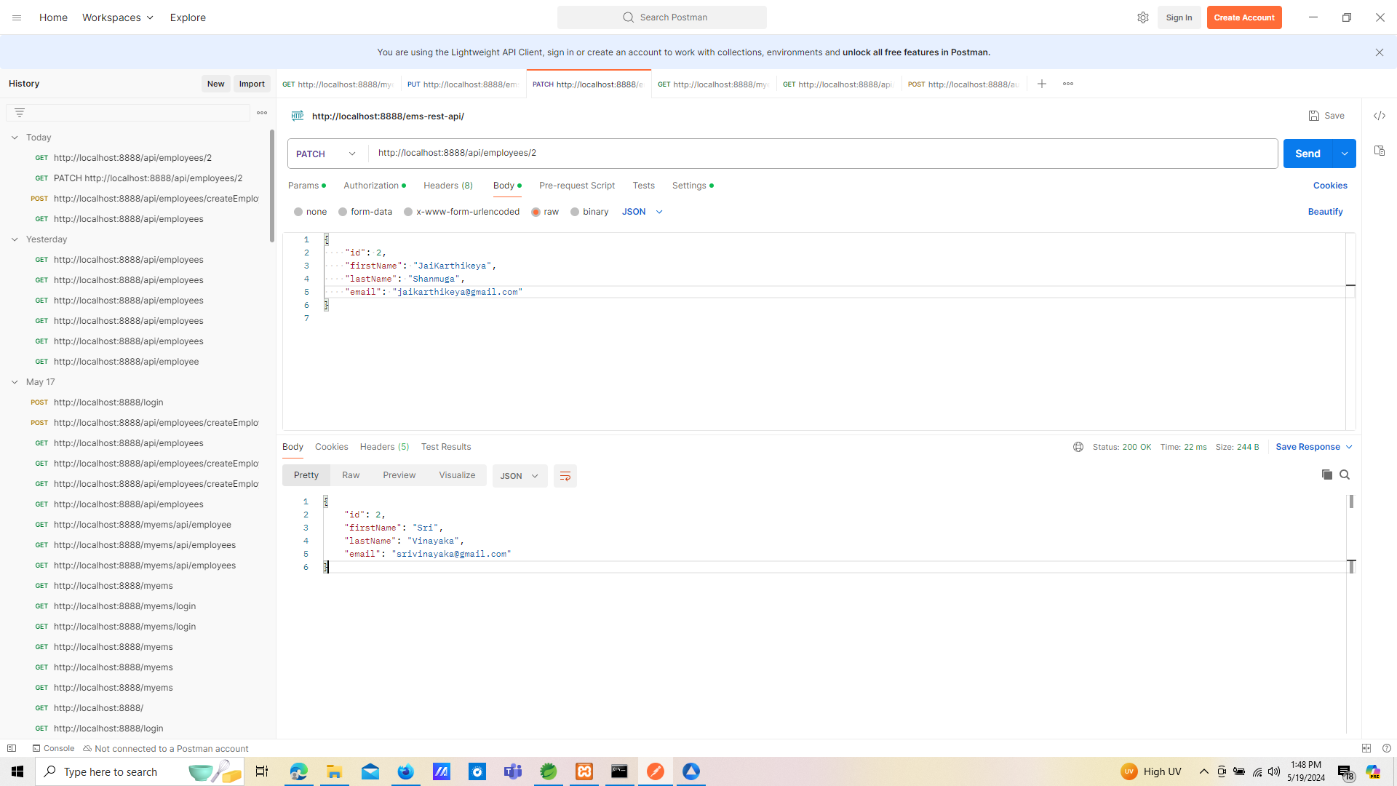

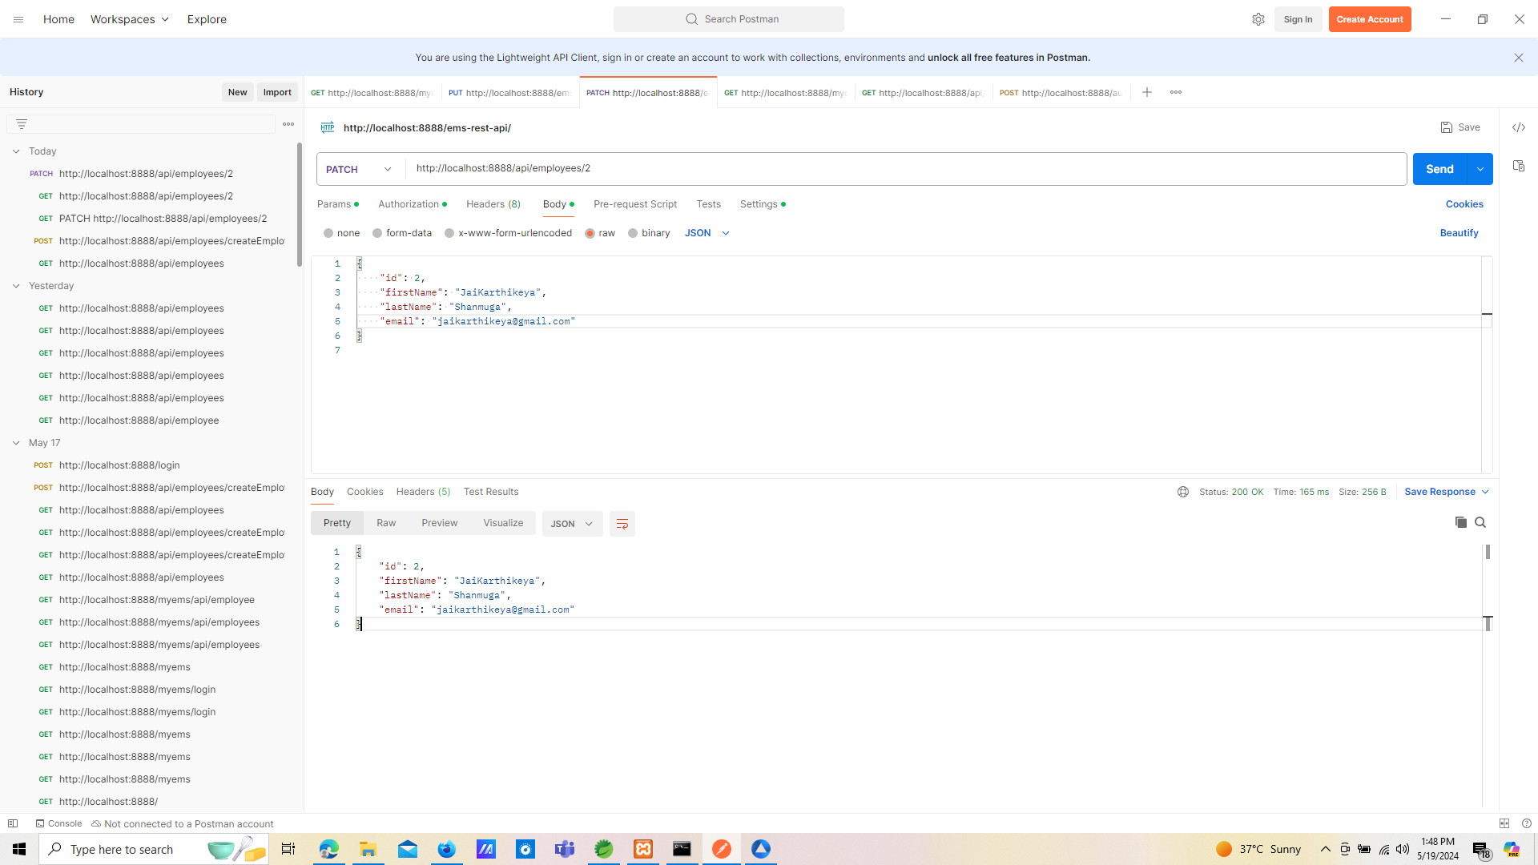

POST http://localhost:8888/api/employees/createEmployee

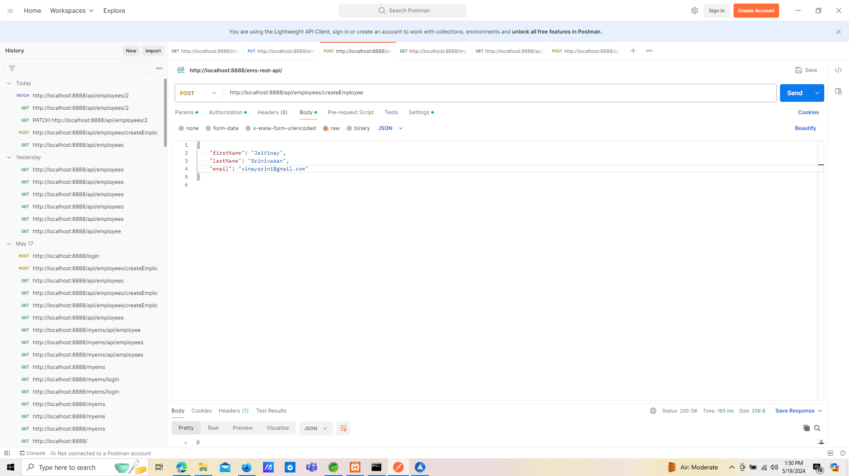

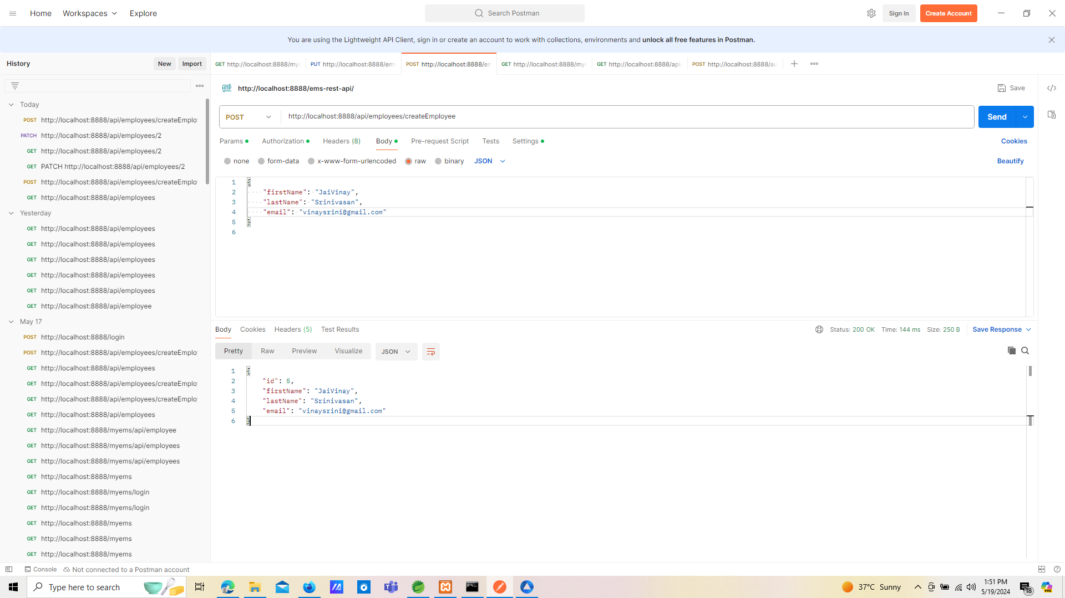

GET http://localhost:8888/api/employees/5

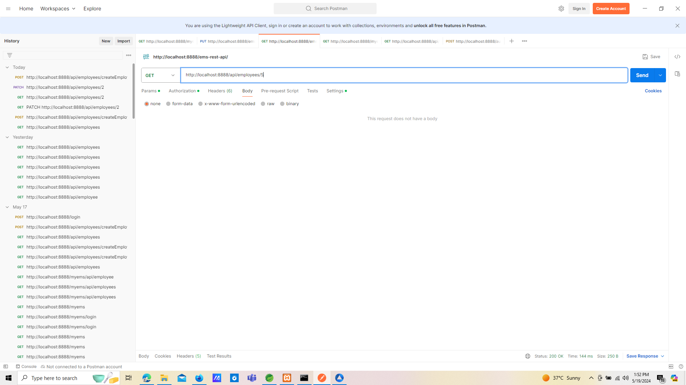

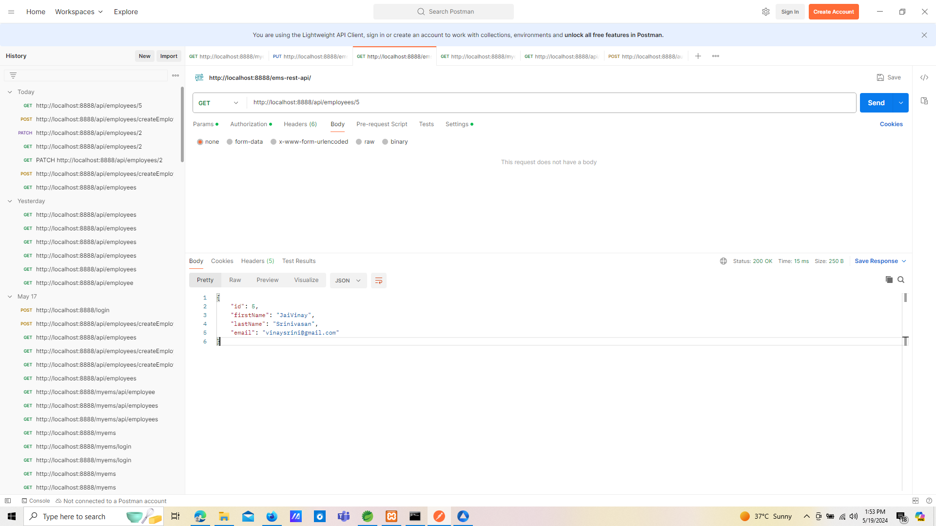

GET http://localhost:8888/api/employees/5

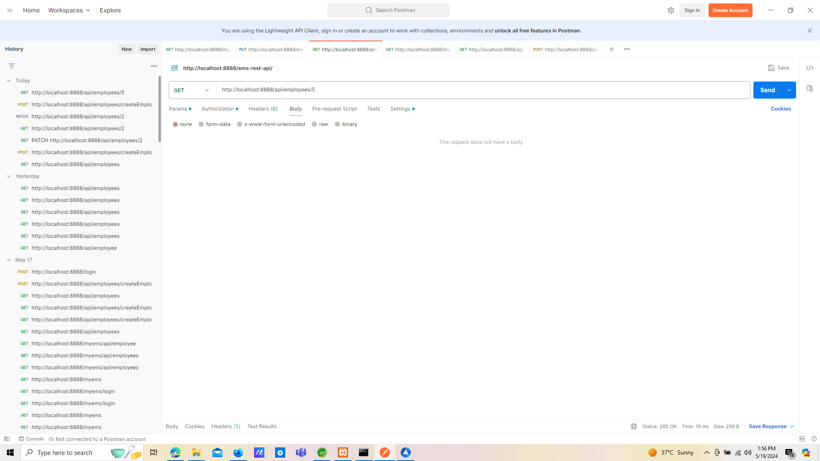

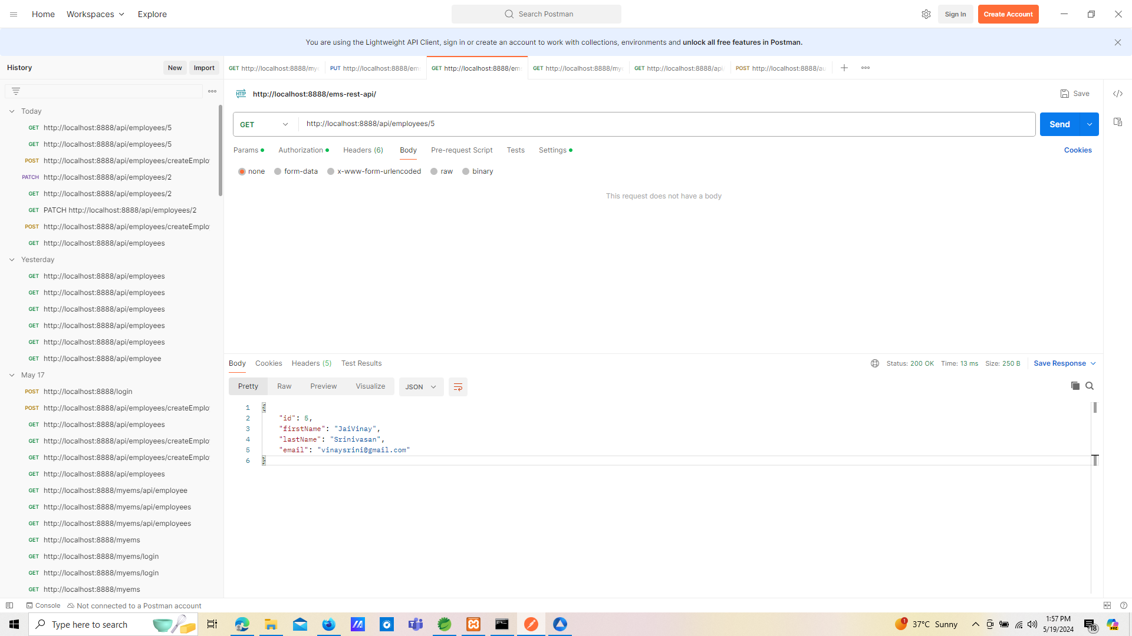

GET http://localhost:8888/api/employees

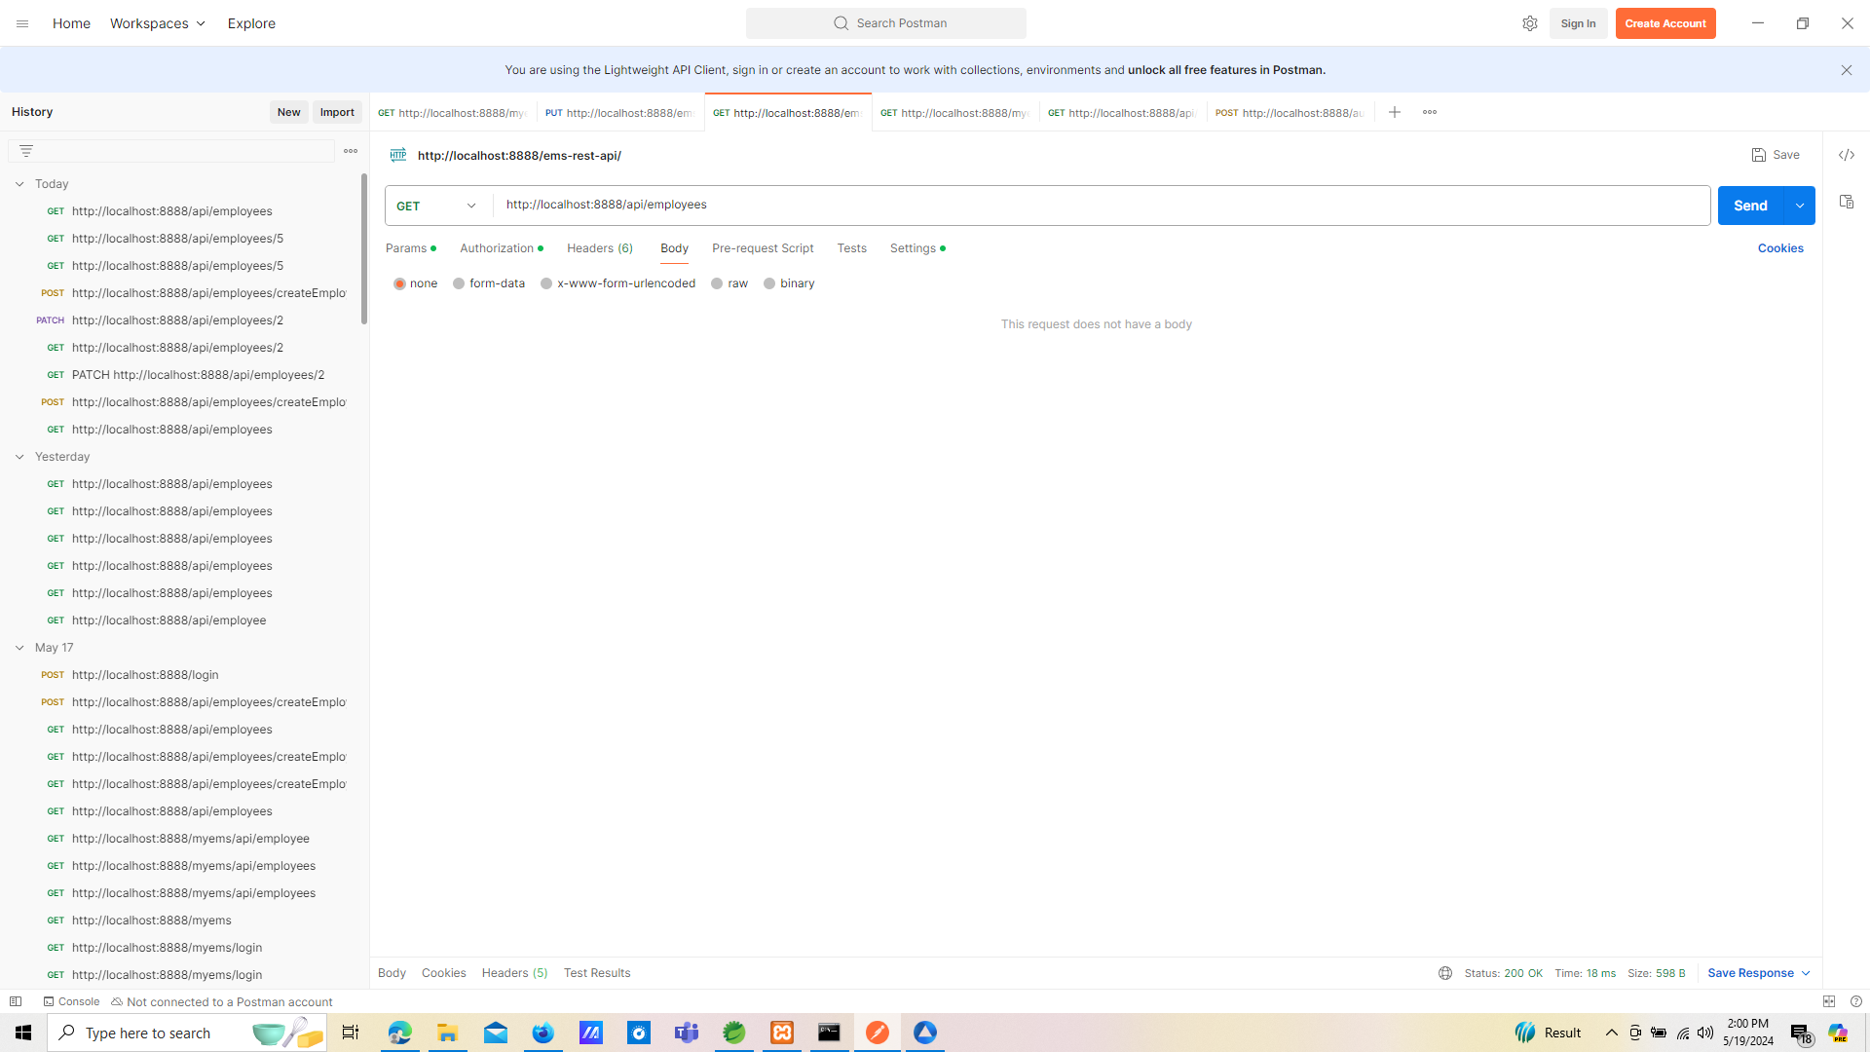

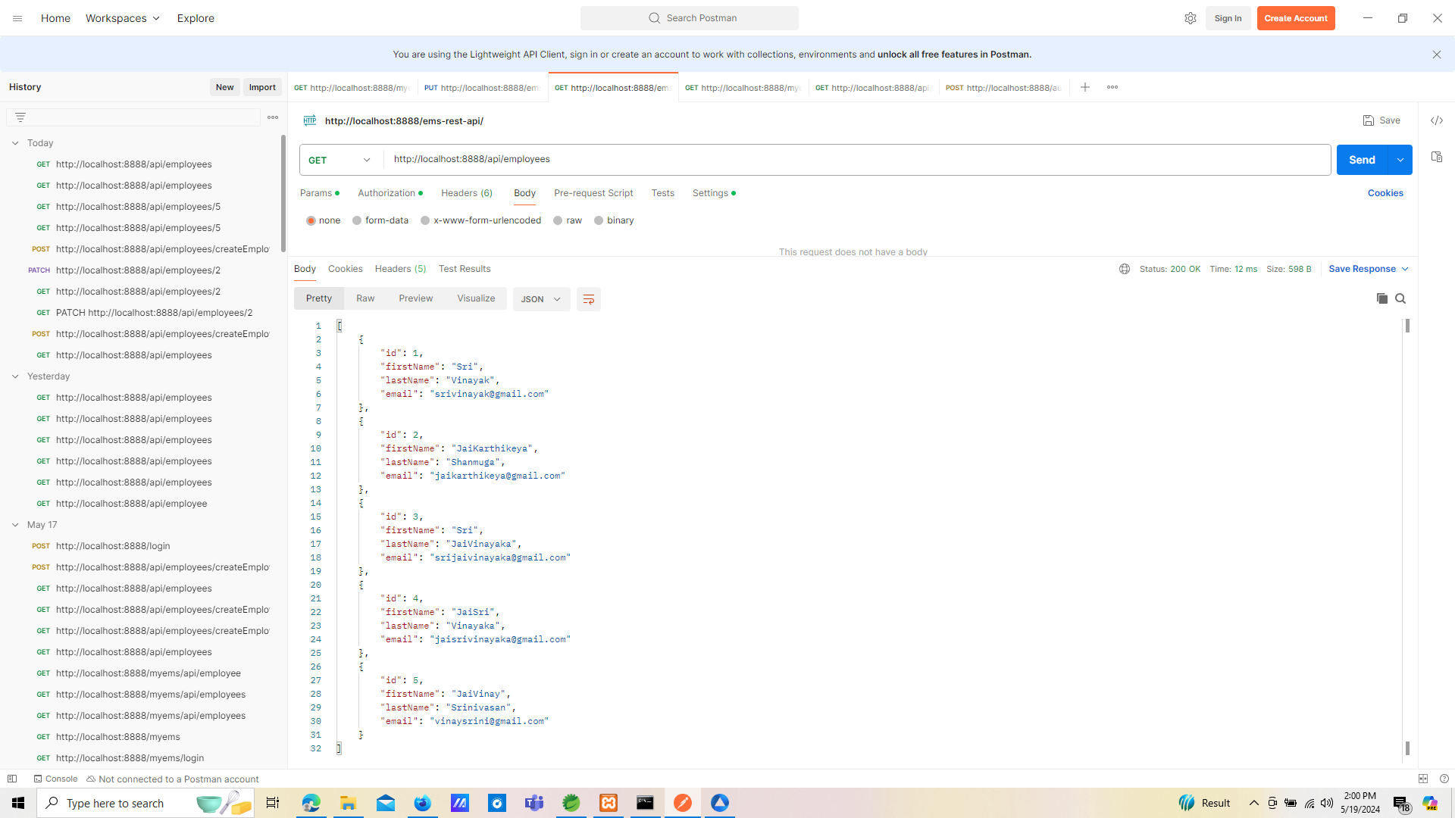

DELETE http://localhost:8888/api/employees/5

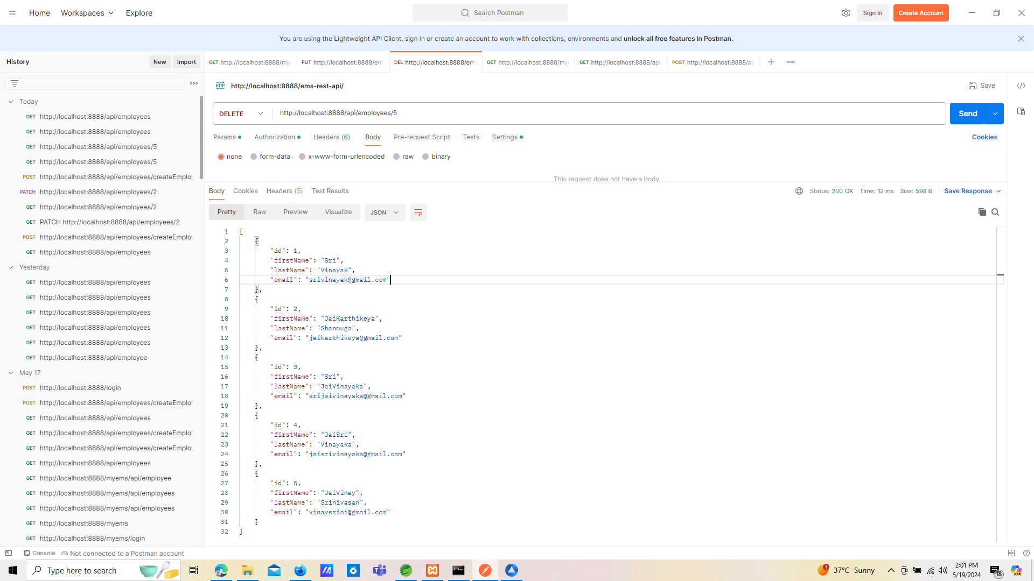

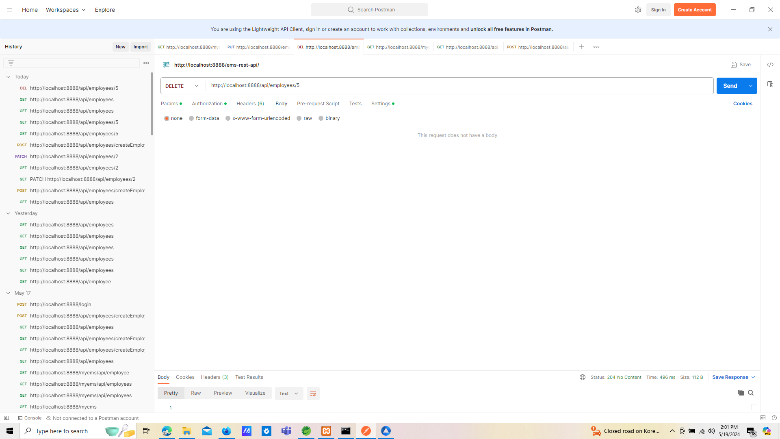

GET http://localhost:8888/api/employees

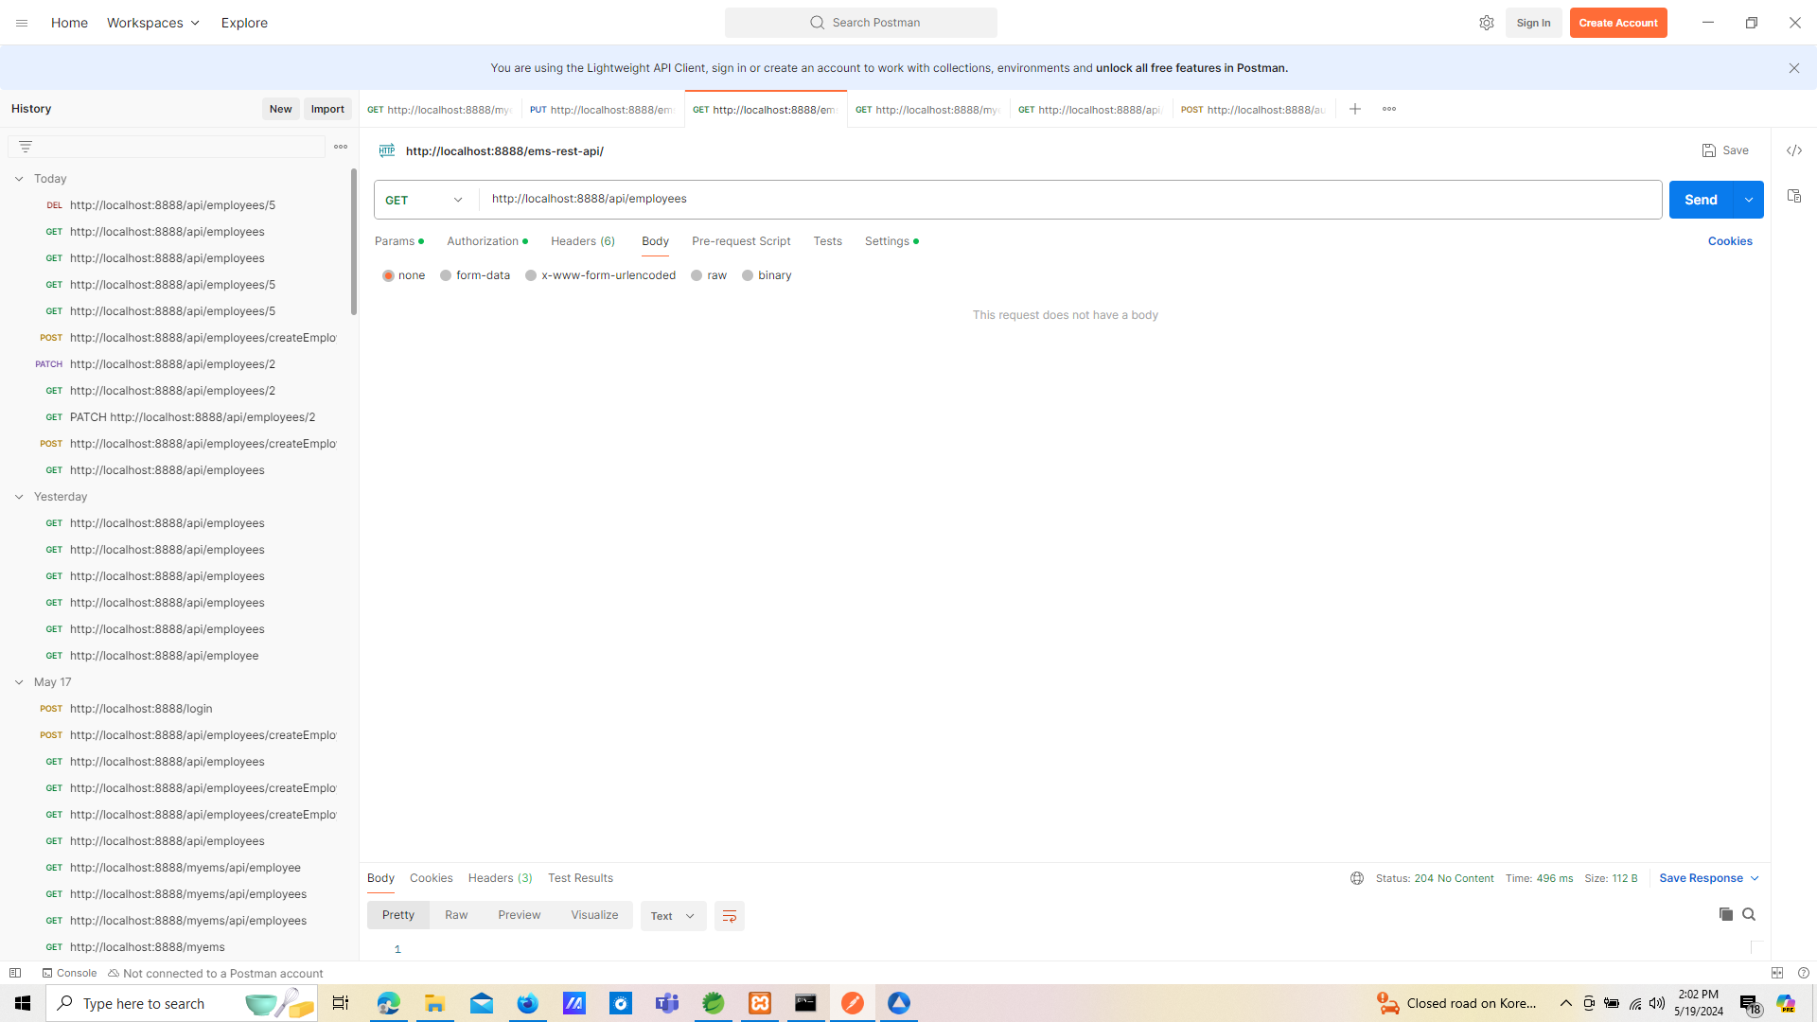

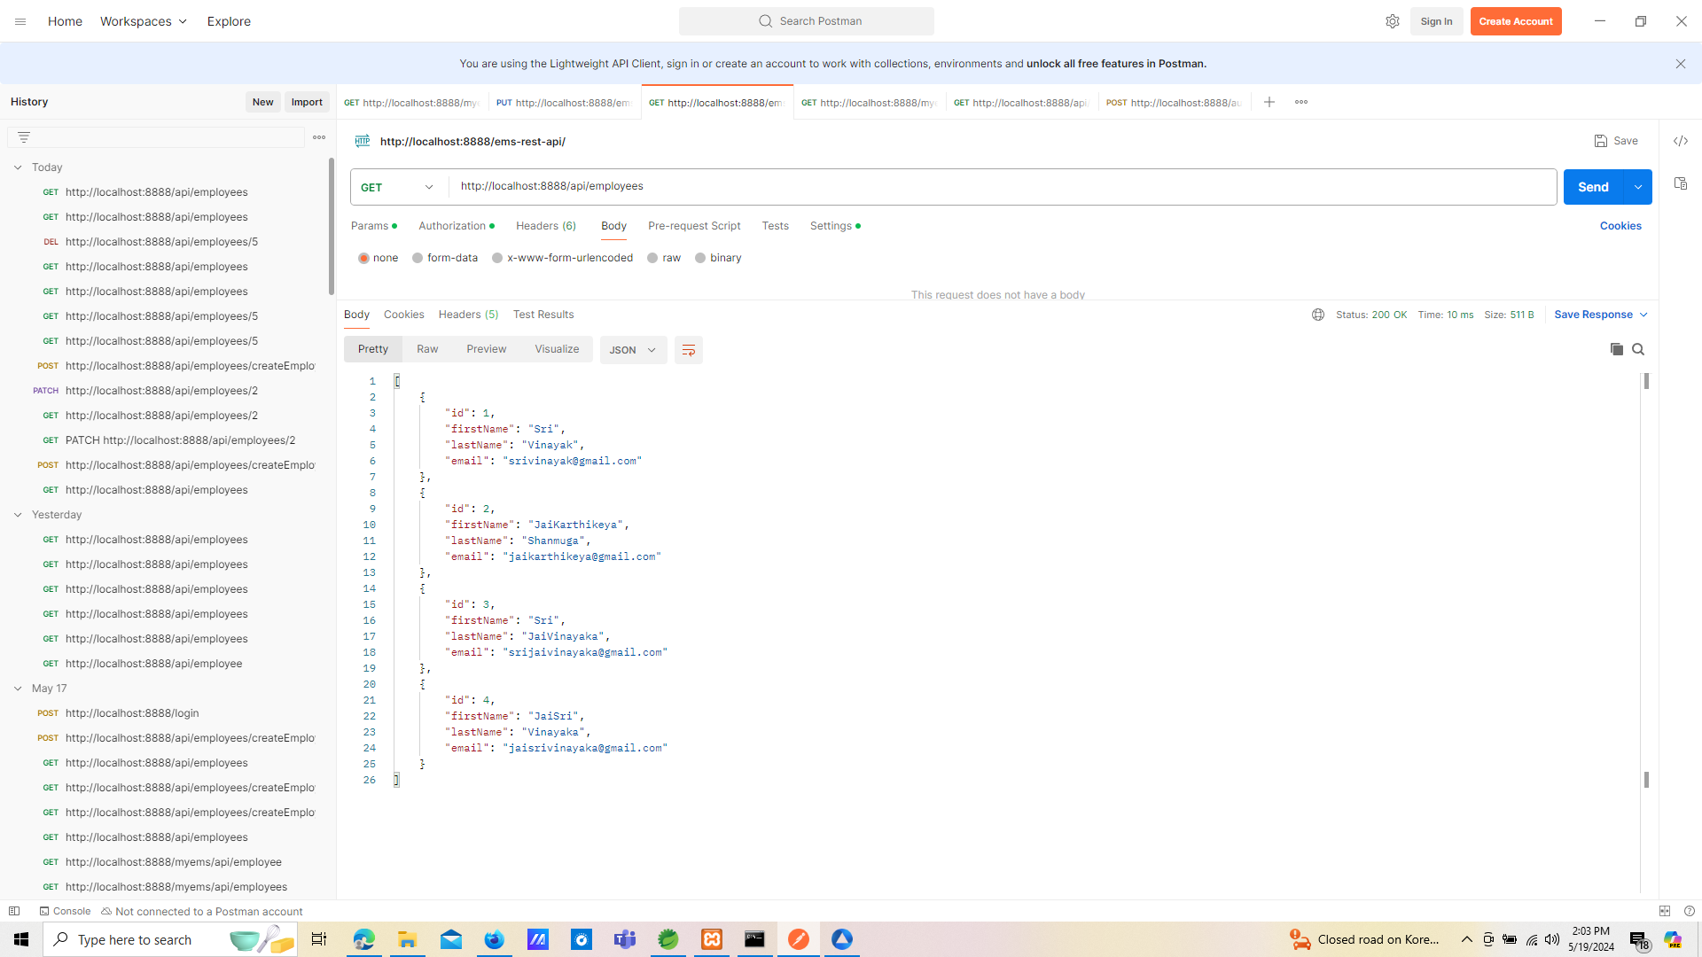

POST http://localhost:8888/api/employees/createEmployee

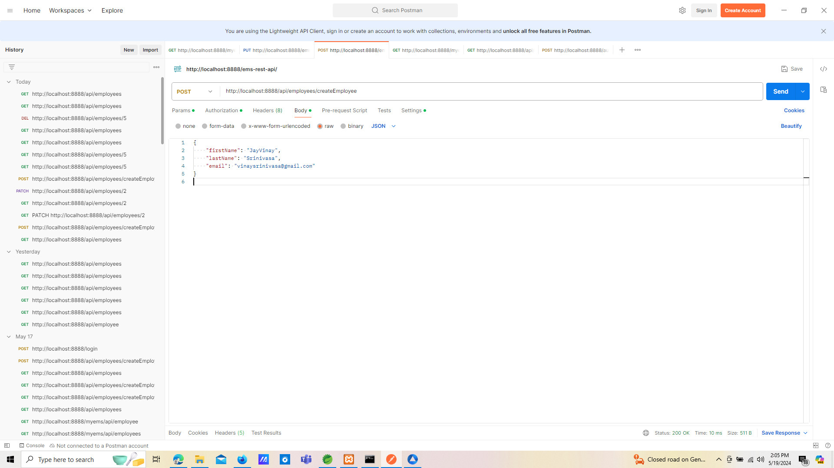

GET http://localhost:8888/api/employees

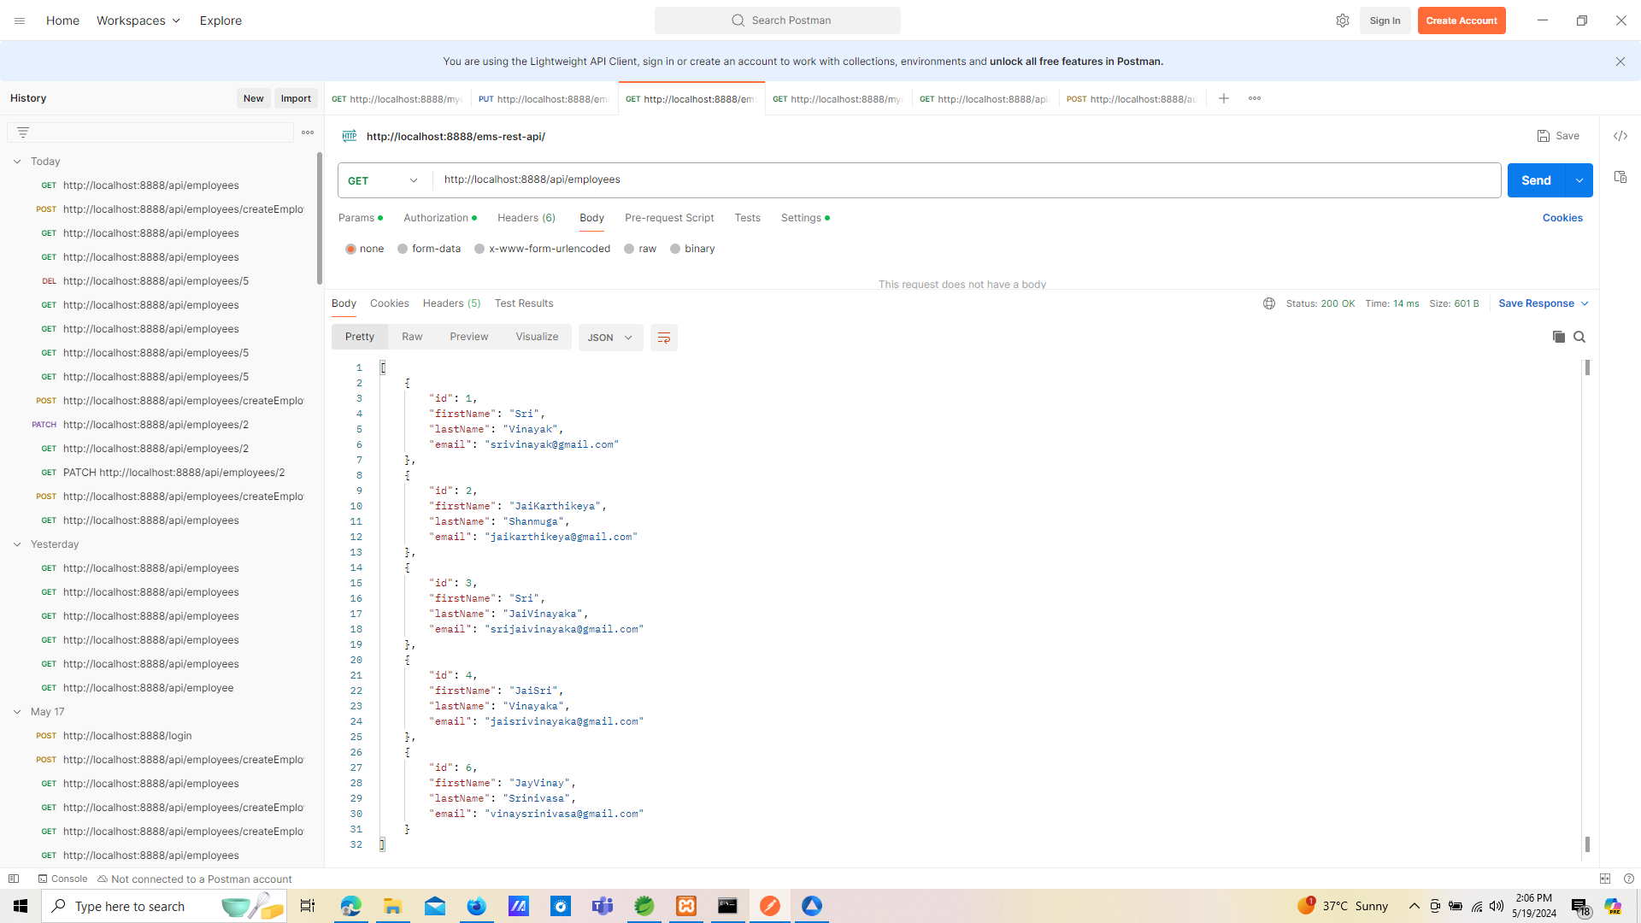

Final Result of Get Employees

[

    {

        "id": 1,

        "firstName": "Sri",

        "lastName": "Vinayak",

        "email": "srivinayak@gmail.com"

    },

    {

        "id": 2,

        "firstName": "JaiKarthikeya",

        "lastName": "Shanmuga",

        "email": "jaikarthikeya@gmail.com"

    },

    {

        "id": 3,

        "firstName": "Sri",

        "lastName": "JaiVinayaka",

        "email": "srijaivinayaka@gmail.com"

    },

    {

        "id": 4,

        "firstName": "JaiSri",

        "lastName": "Vinayaka",

        "email": "jaisrivinayaka@gmail.com"

    },

    {

        "id": 6,

        "firstName": "JayVinay",

        "lastName": "Srinivasa",

        "email": "vinaysrinivasa@gmail.com"

    }

]